**Name : Sarthak Shandilya**

**Python Assignment 1**

In this assignment the program can be started with app.py

If you run the program you’ll get 10 options and you have to select choices accordingly from 1 to 10 as shown in the program.

1. Customer Registration
2. Update products info
3. Placing new order
4. Track order status
5. Inventory management
6. Sales reporting
7. Customer Account Update (phone, address, email)
8. Payment Processing
9. Product search with recommendations based on category.
10. Exit from application.

**App.py**

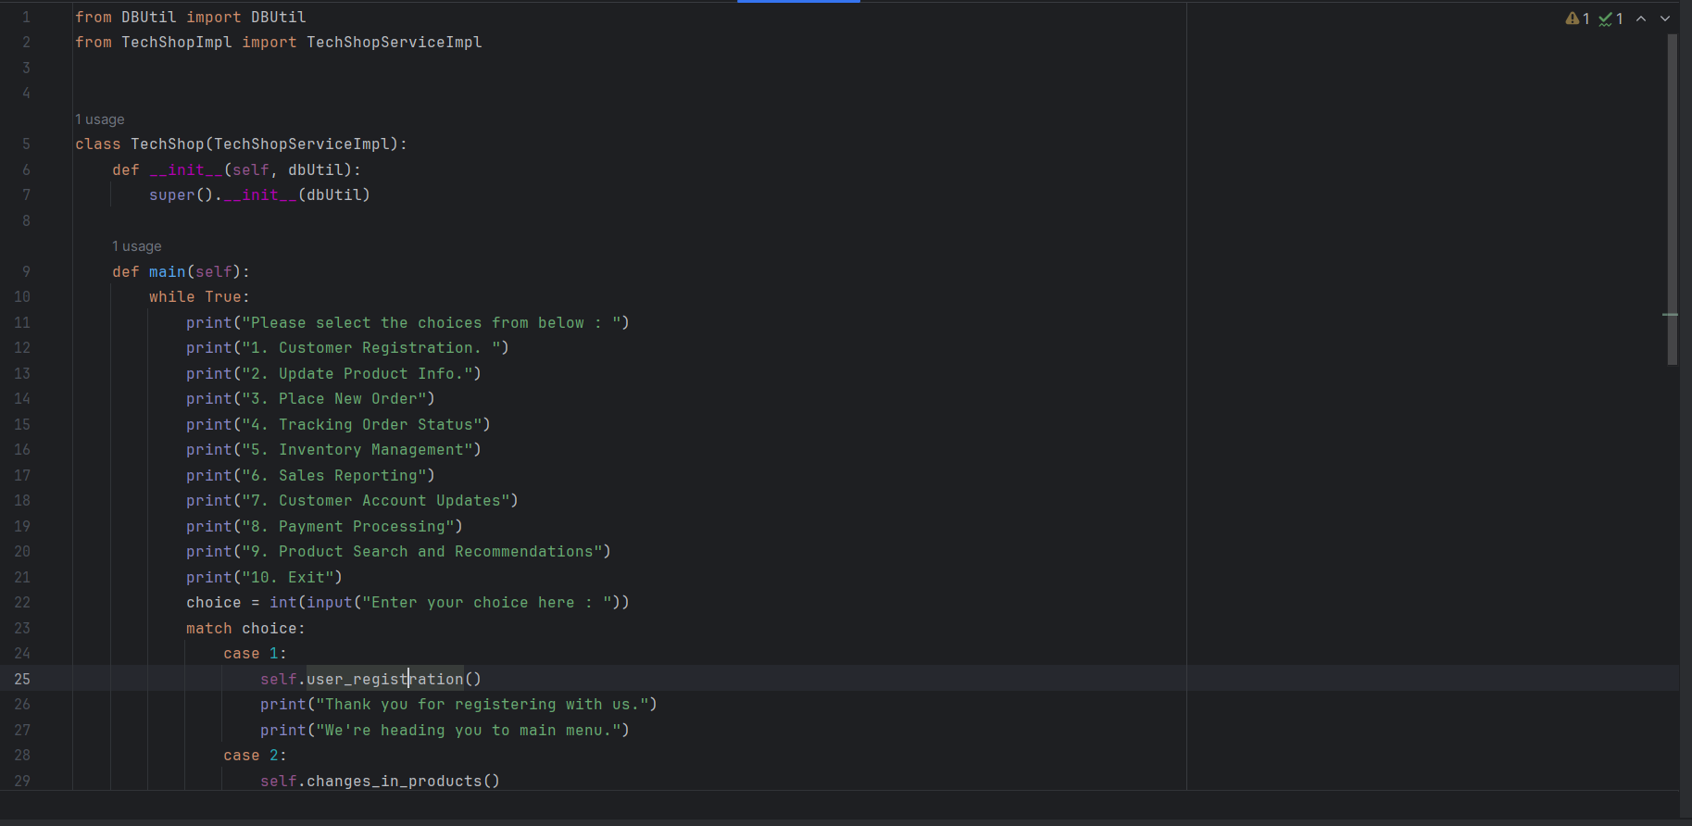

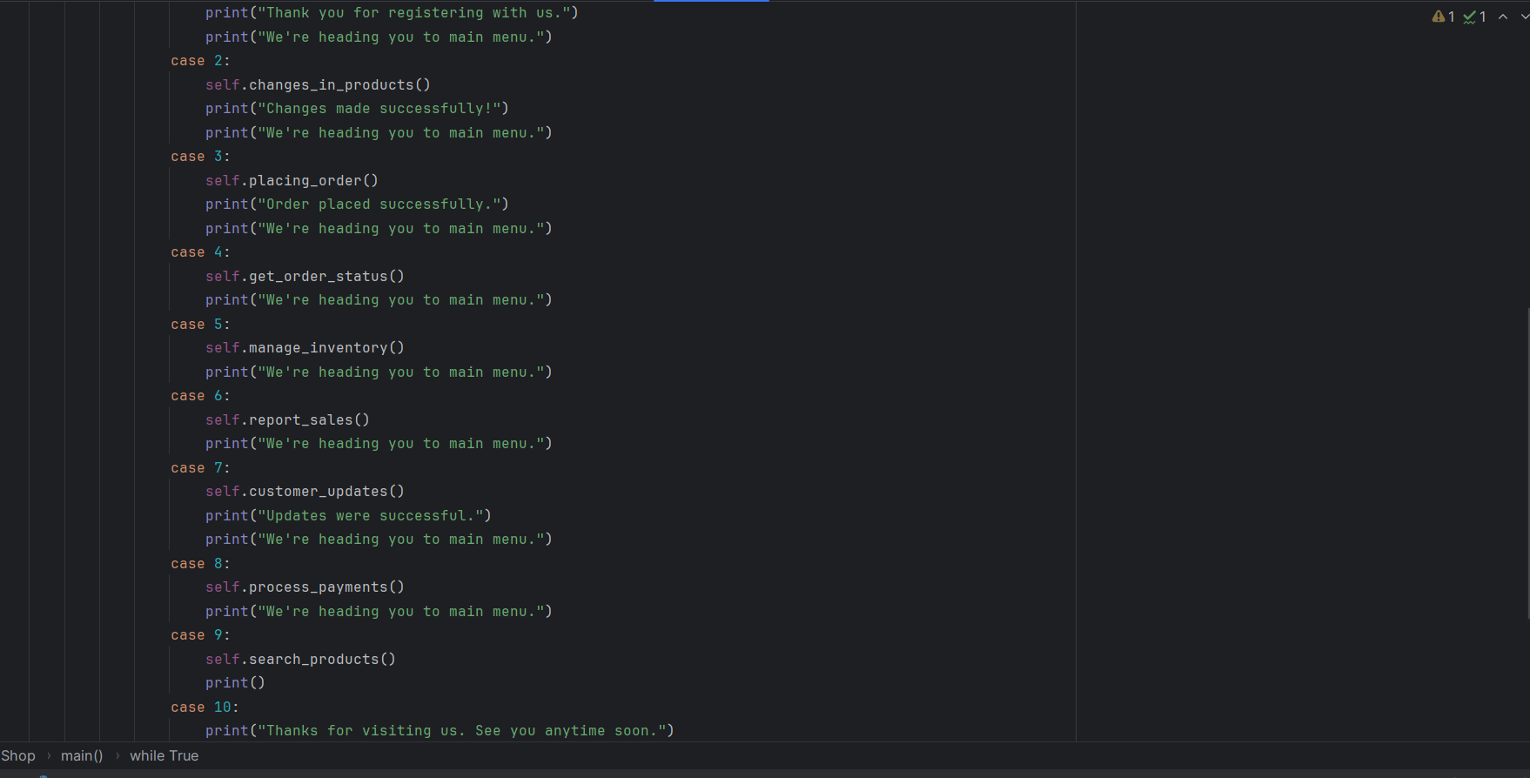

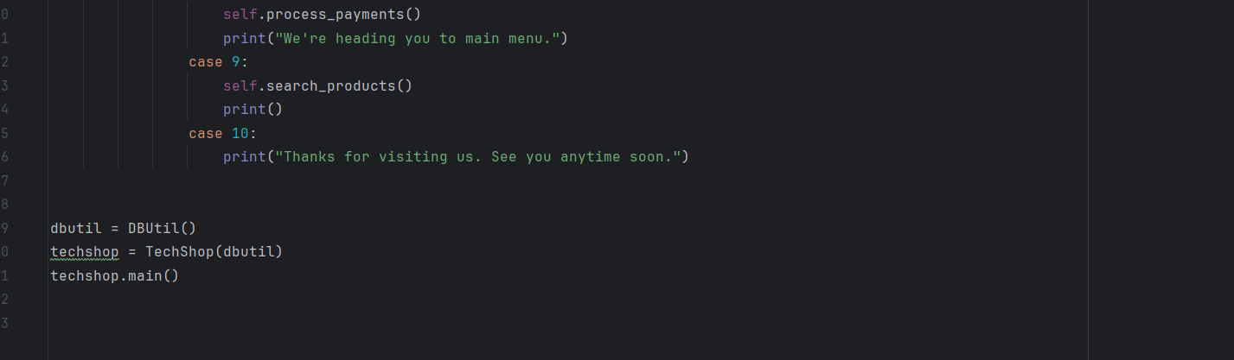

1. **Customer Registration:**

**Code:**

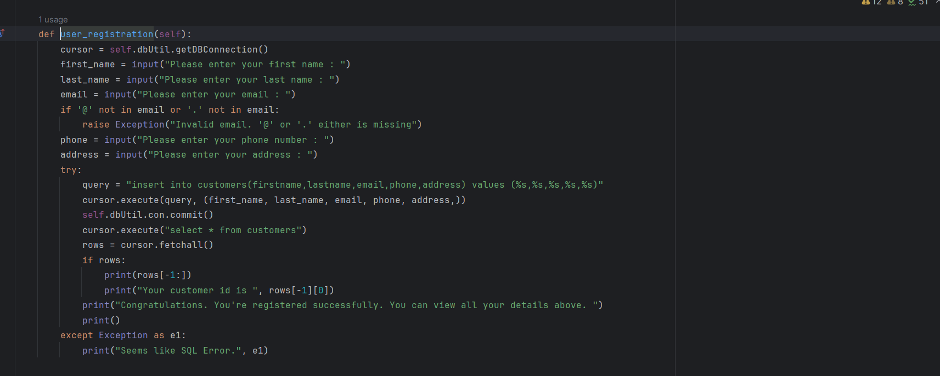

**Output:**

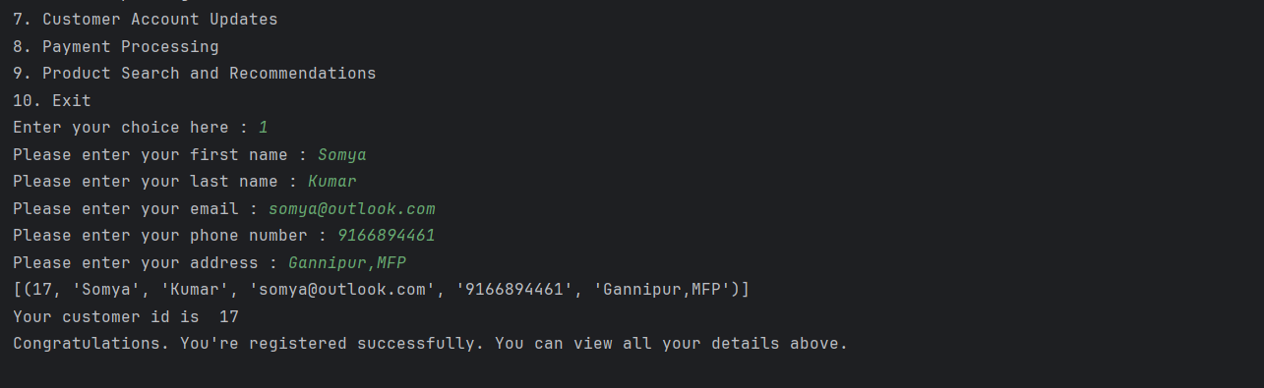

**Updated in database:**

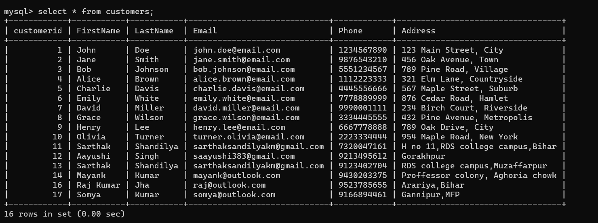

1. **Update product info:**

**Code:**

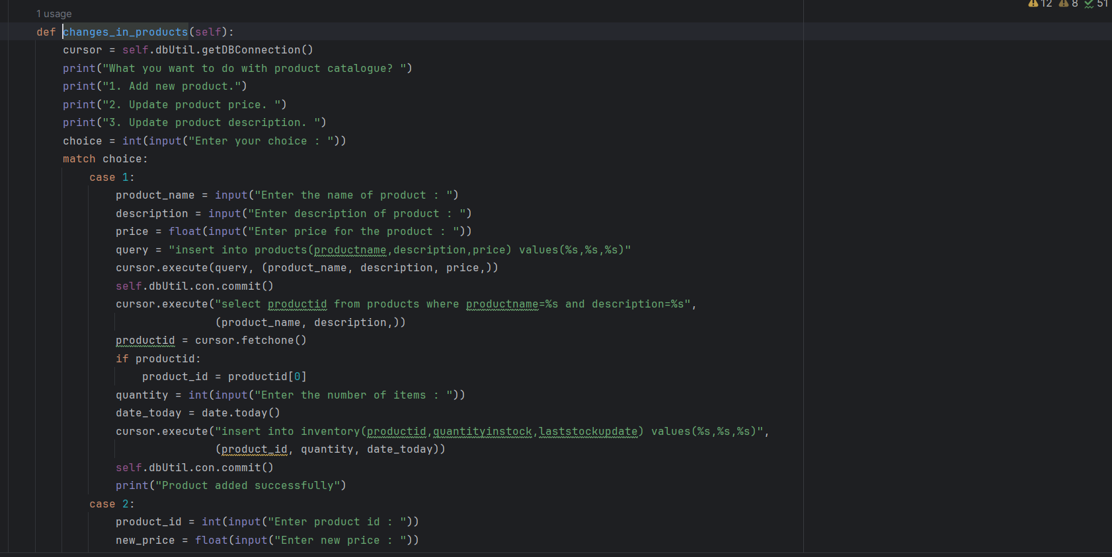

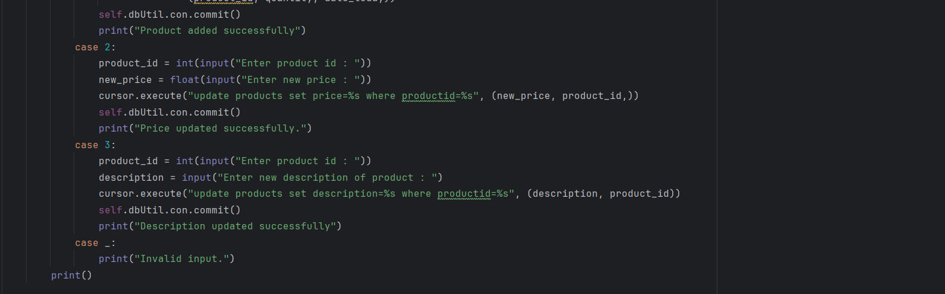

**Output:**

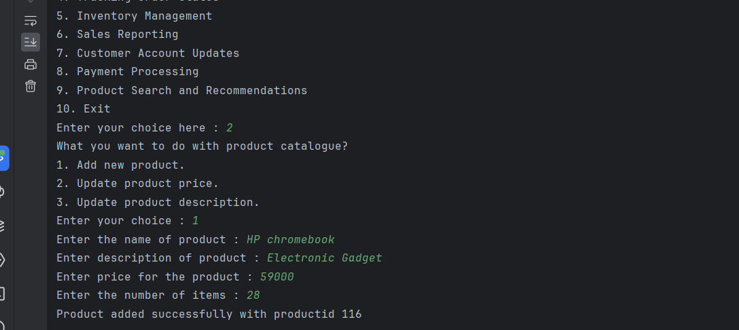

**Updated in product and inventory database:**

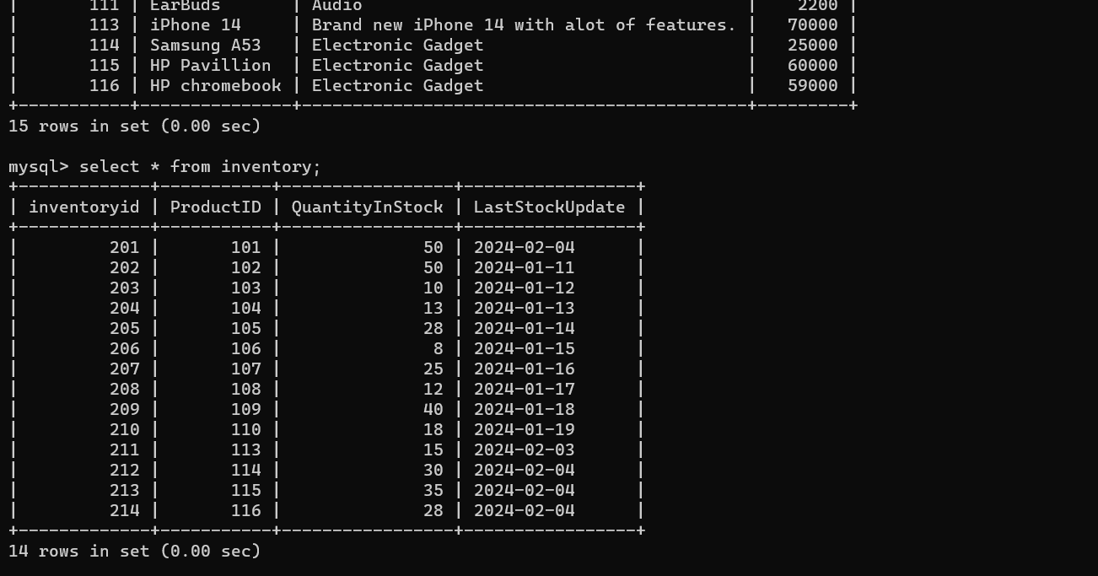

**Updating price:**

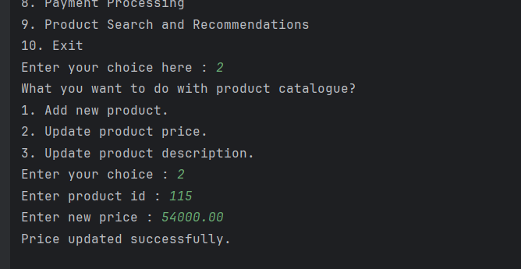

**Reflected in database:**

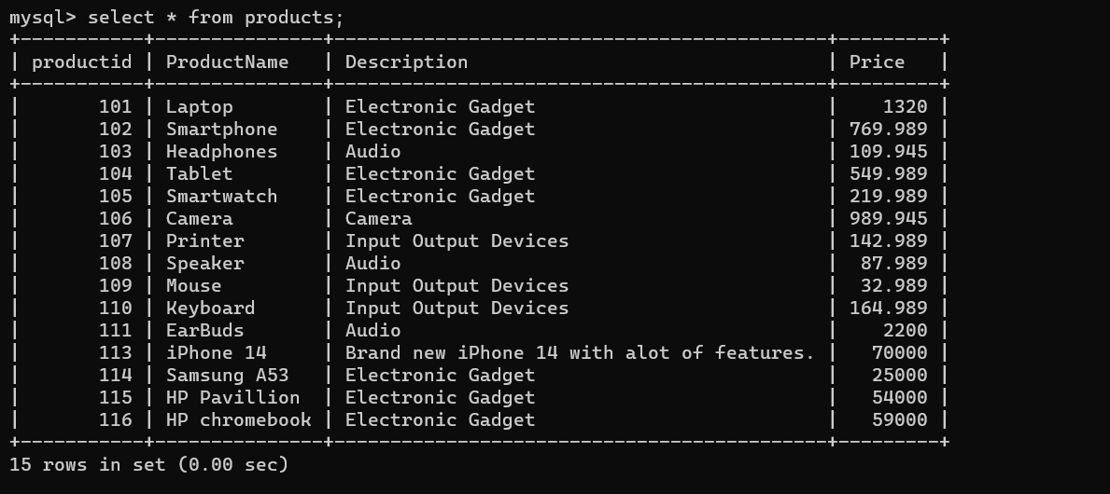

1. **Placing new order:**

**Code:**

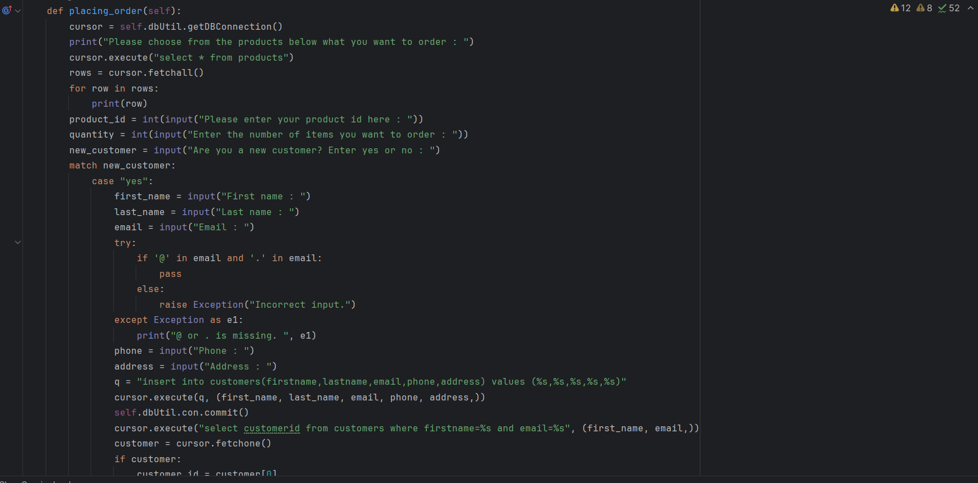

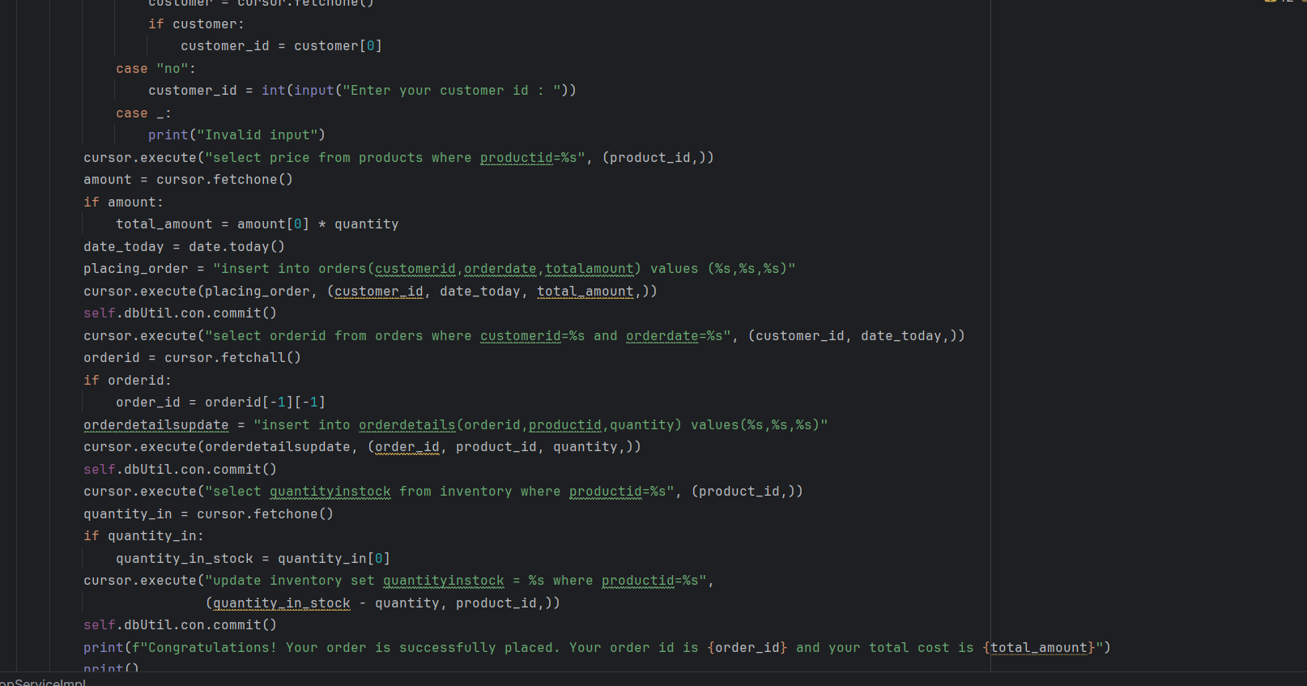

**Placing order for already existing customer:**

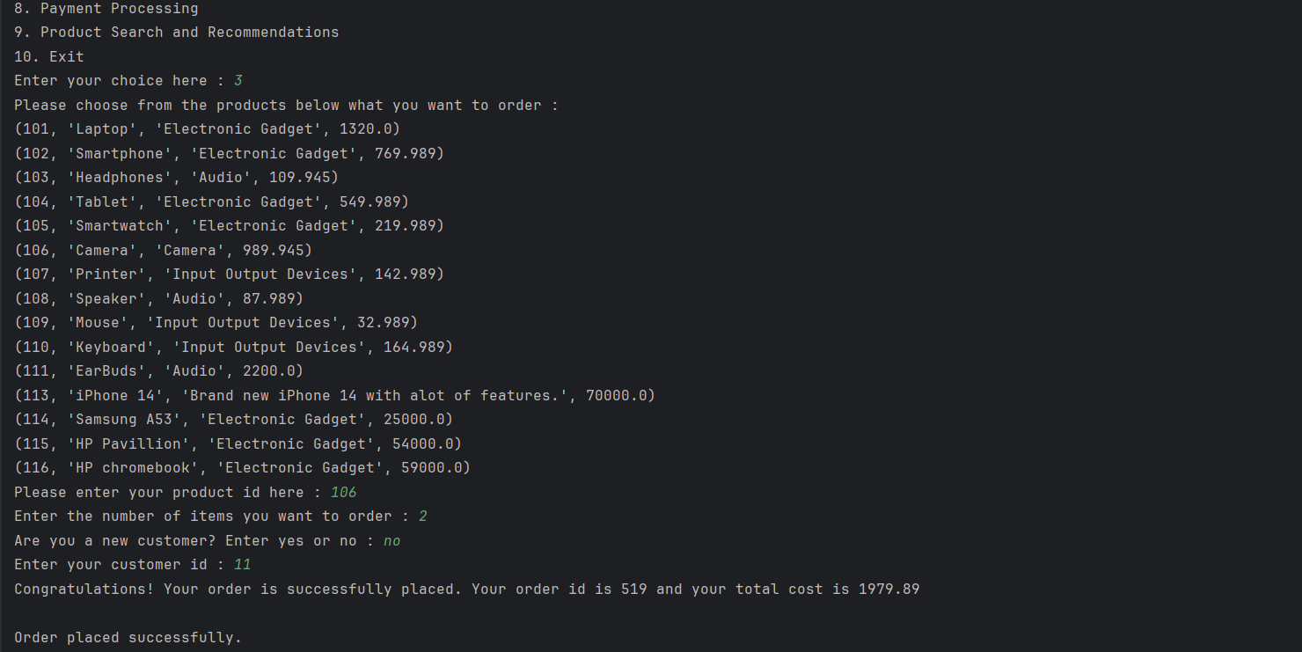

**Placing order for new customer:**

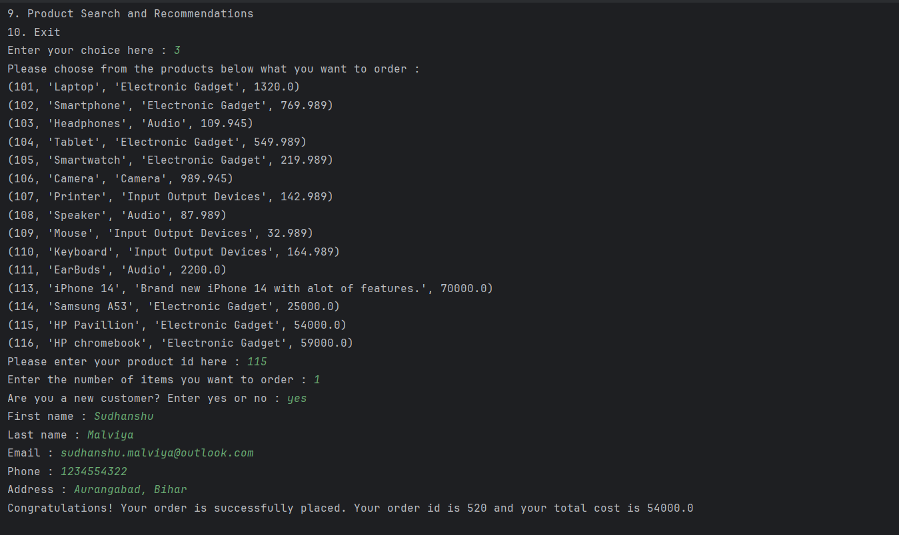

**Updates reflecting in database:**

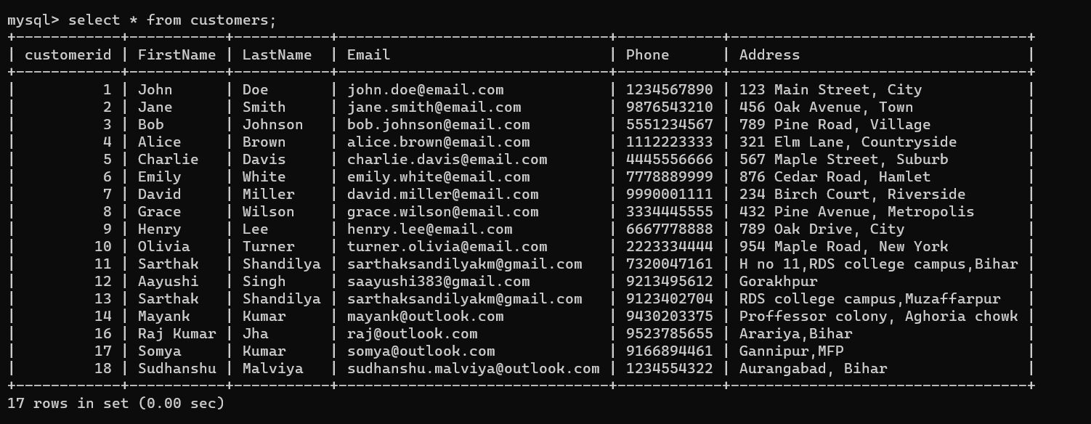

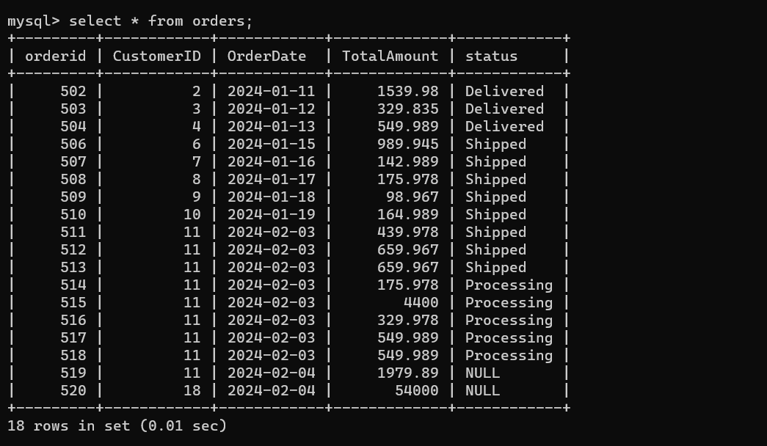

**Note:** Order status we will be updating in further part of the project

1. **Track order status**

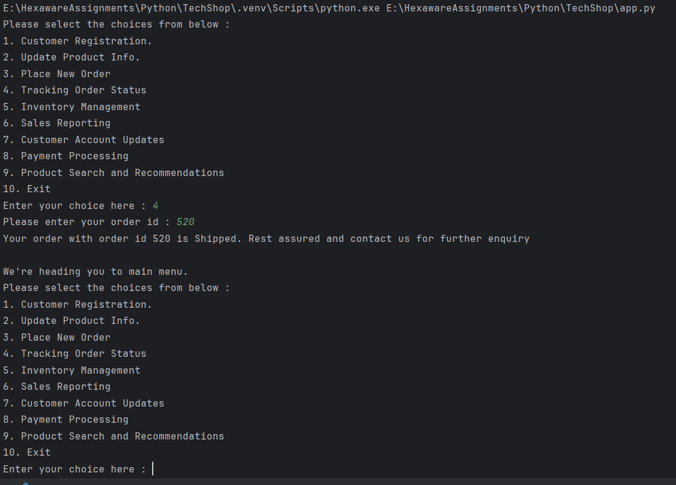

1. **Inventory Management**

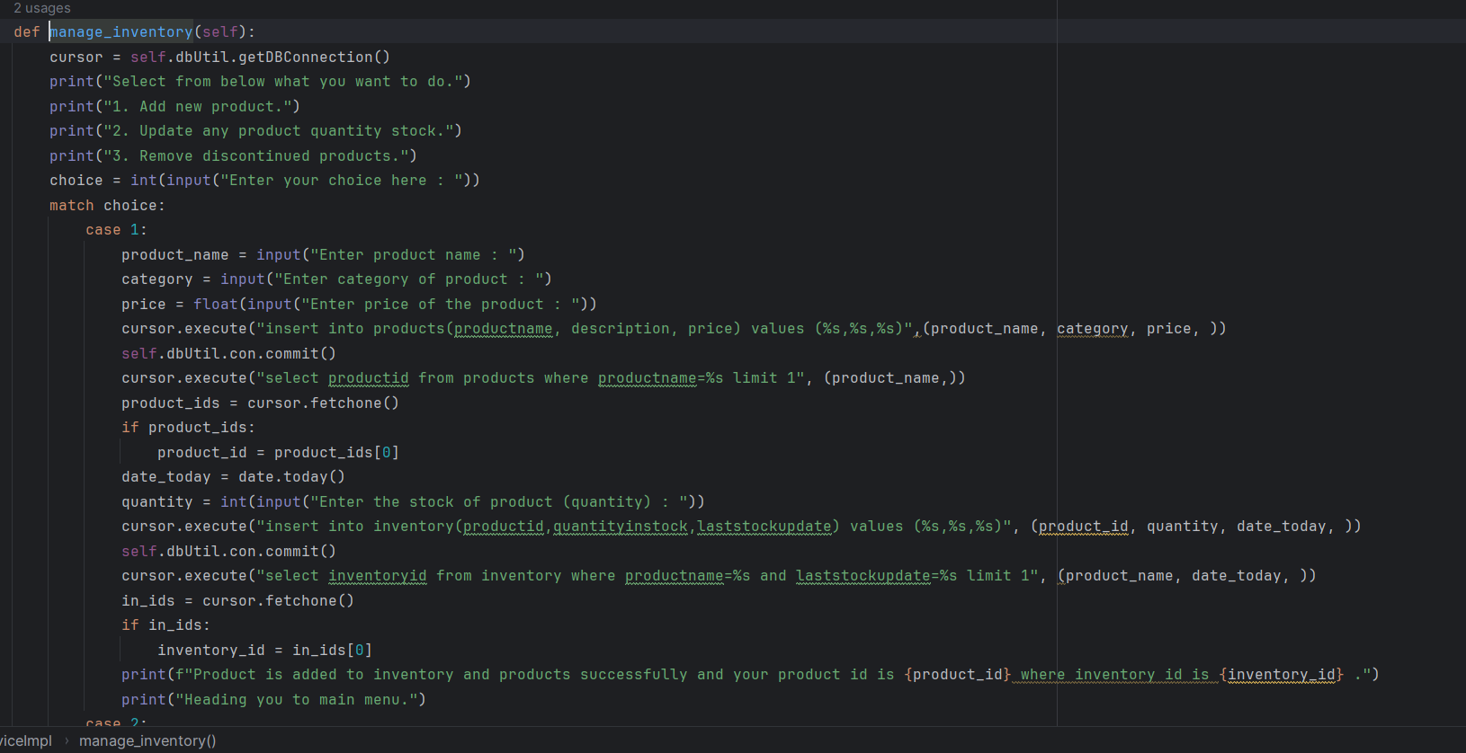

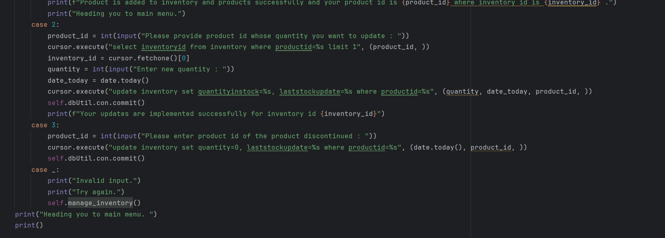

**Output:**

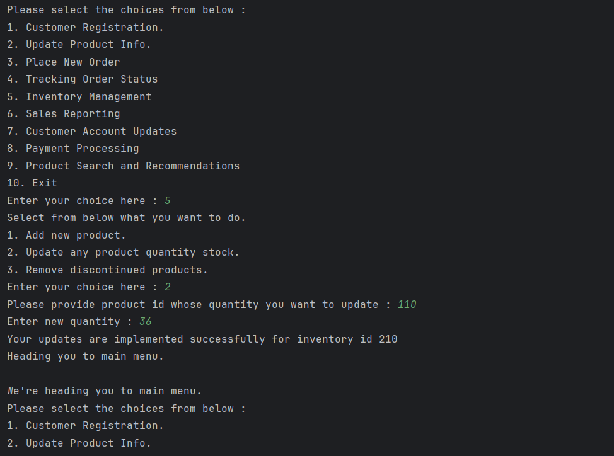

1. **Sales reporting**

**Code:**

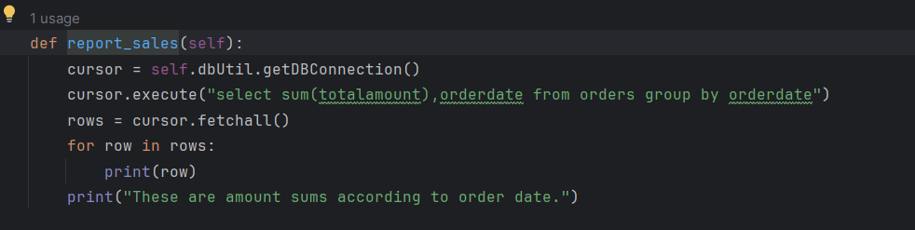

**Output:**

**Note:** Sales report is according to order date.

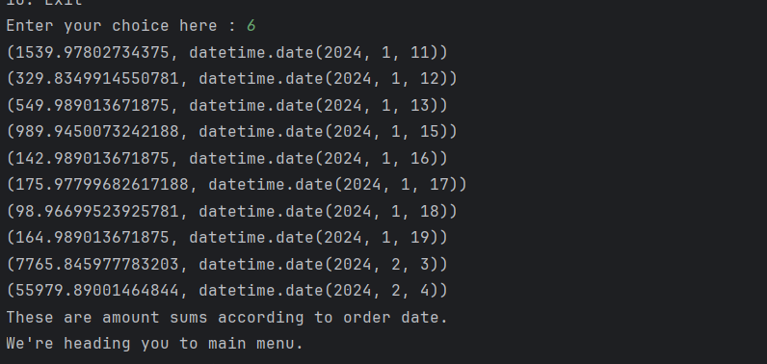

1. **Customer Account Updates:**

**Code:**

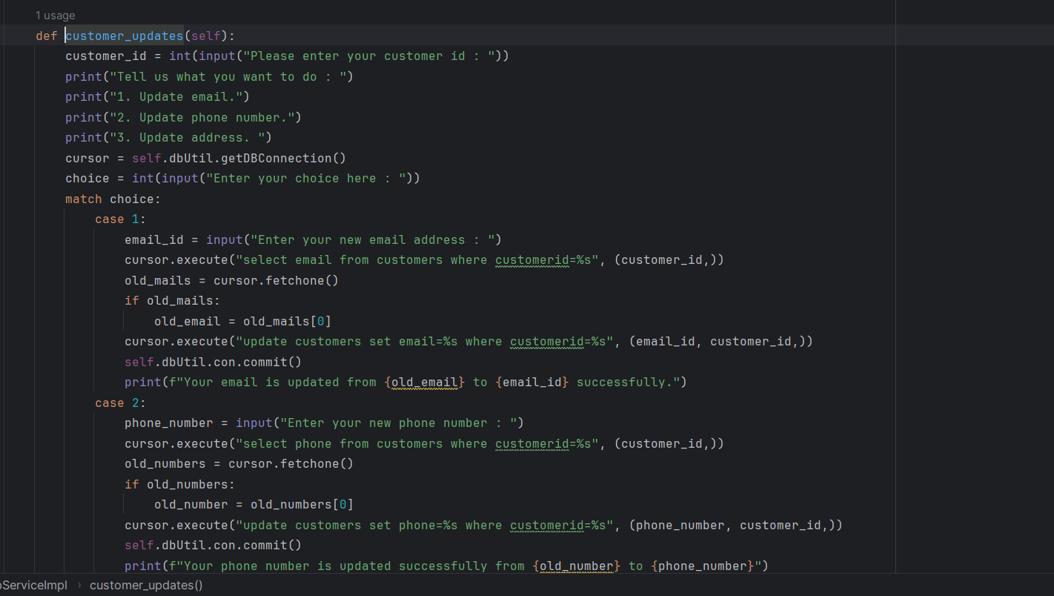

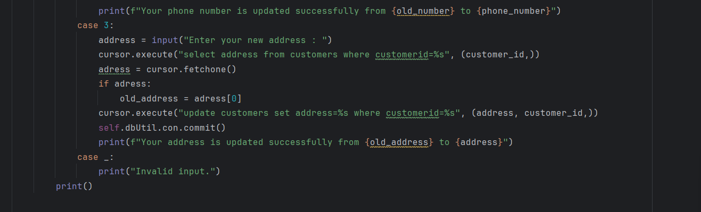

**Output:**

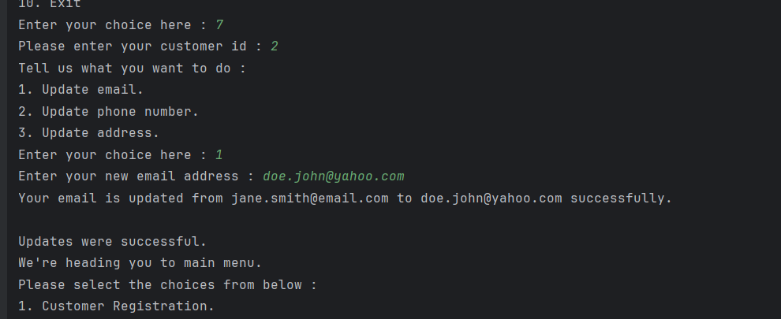

**Updates updated in database:**

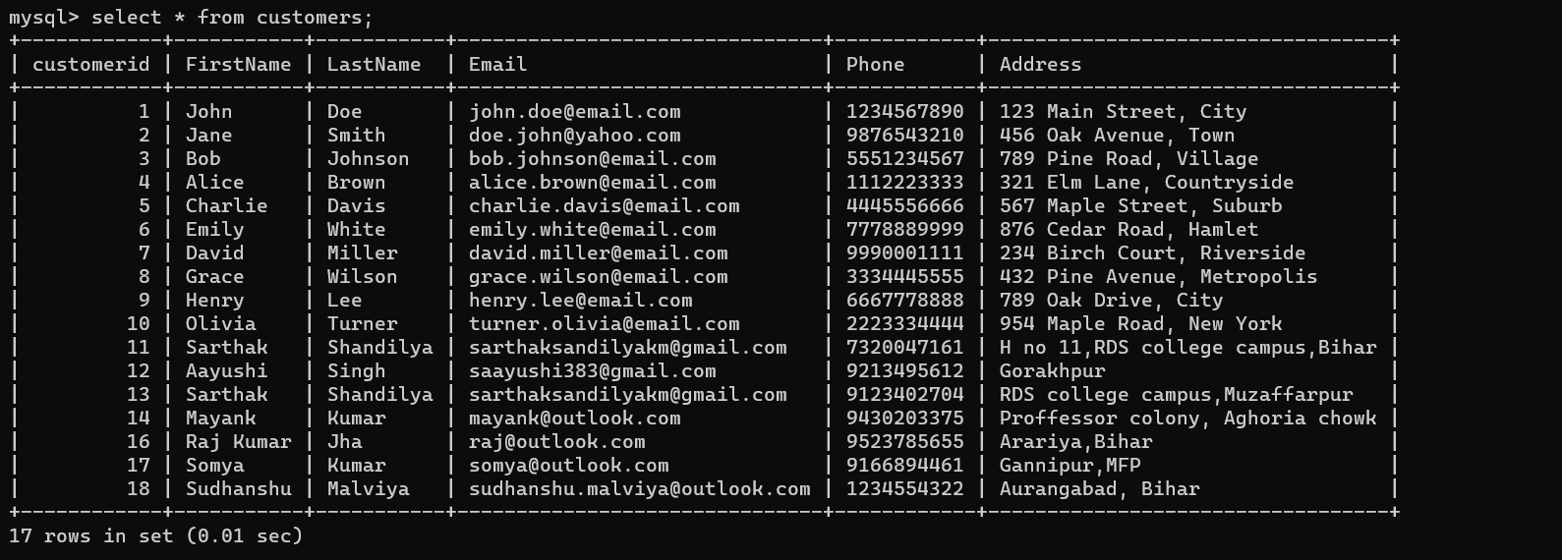

**Note:** Email updated for customer with customer id 2.

1. **Payment processing**

**Since payment method and every info was not available I left this section to update later on.**

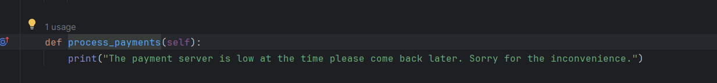

1. **Product Search and Recommendations:**

**Code:**

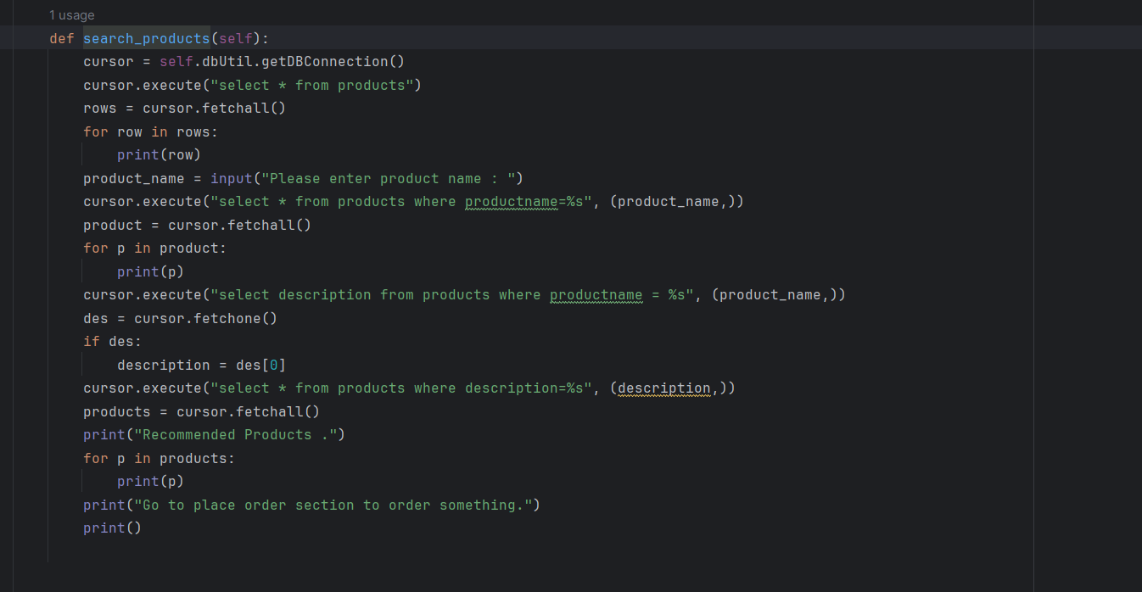

**Output:**

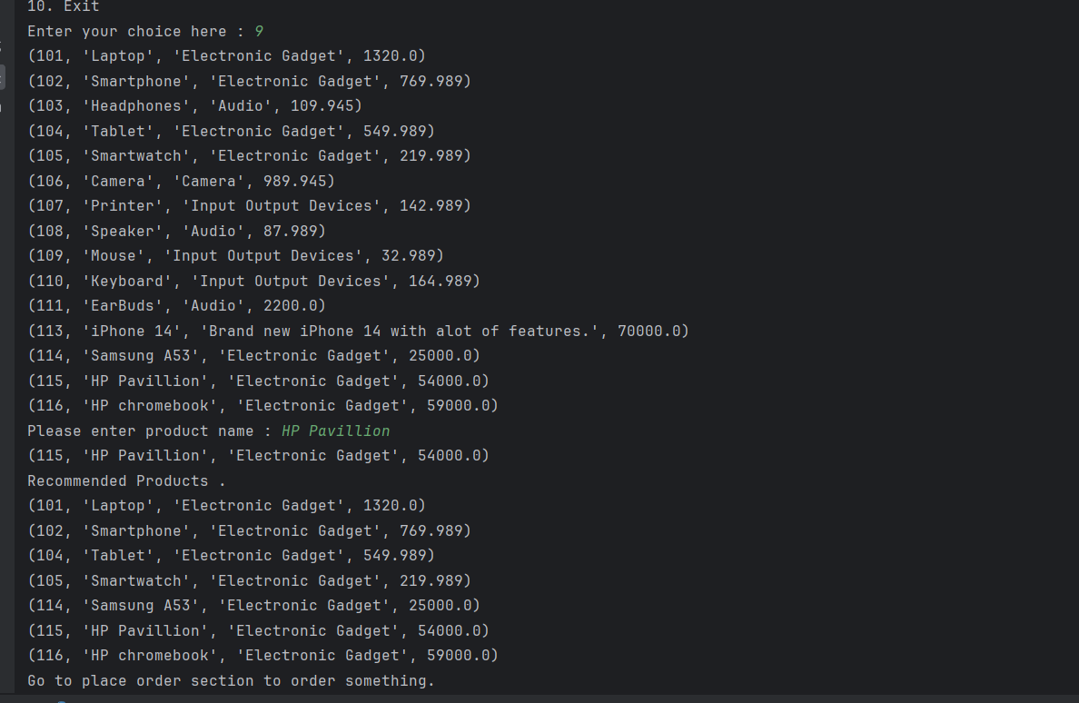

**Abstract methods/Interface for TechShopService:**

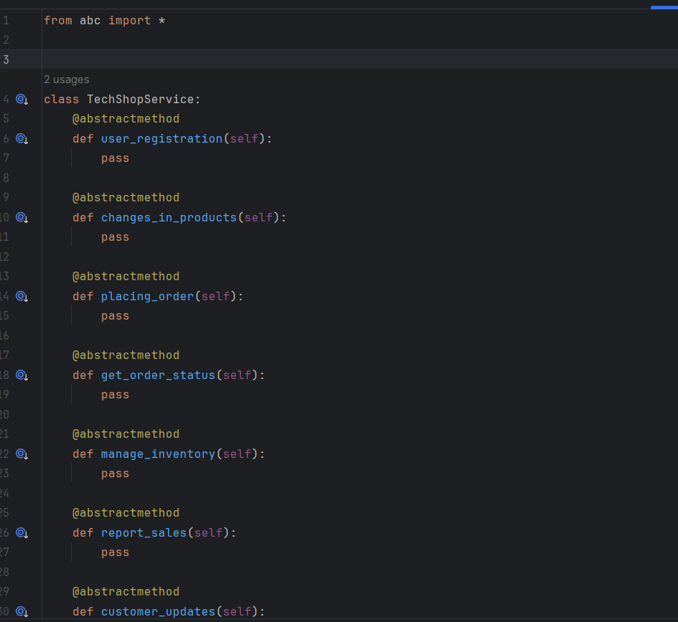

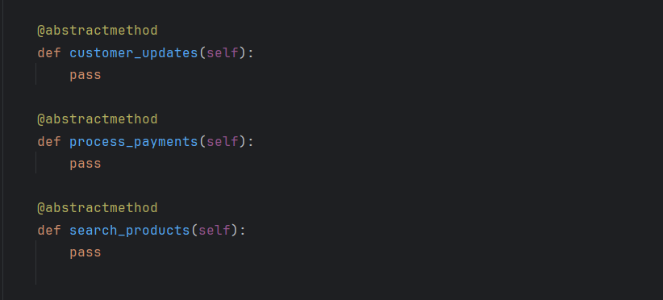

**TechShop Service Provider Implementation:**

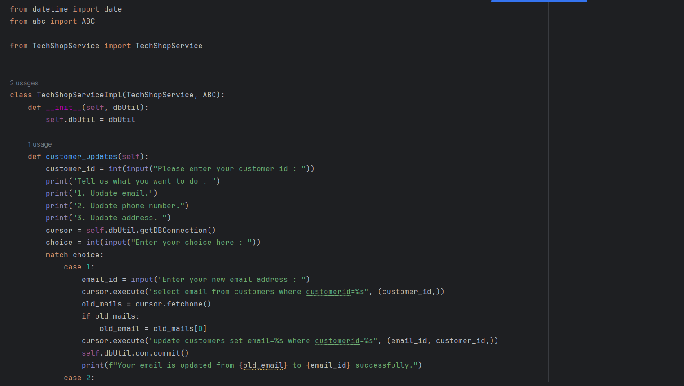

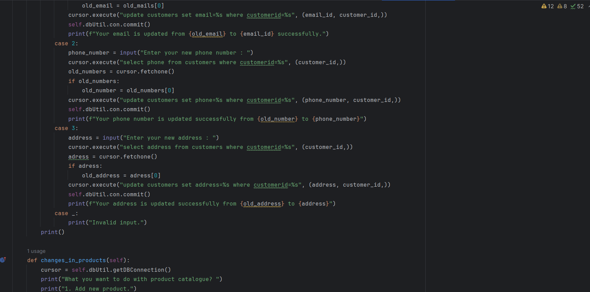

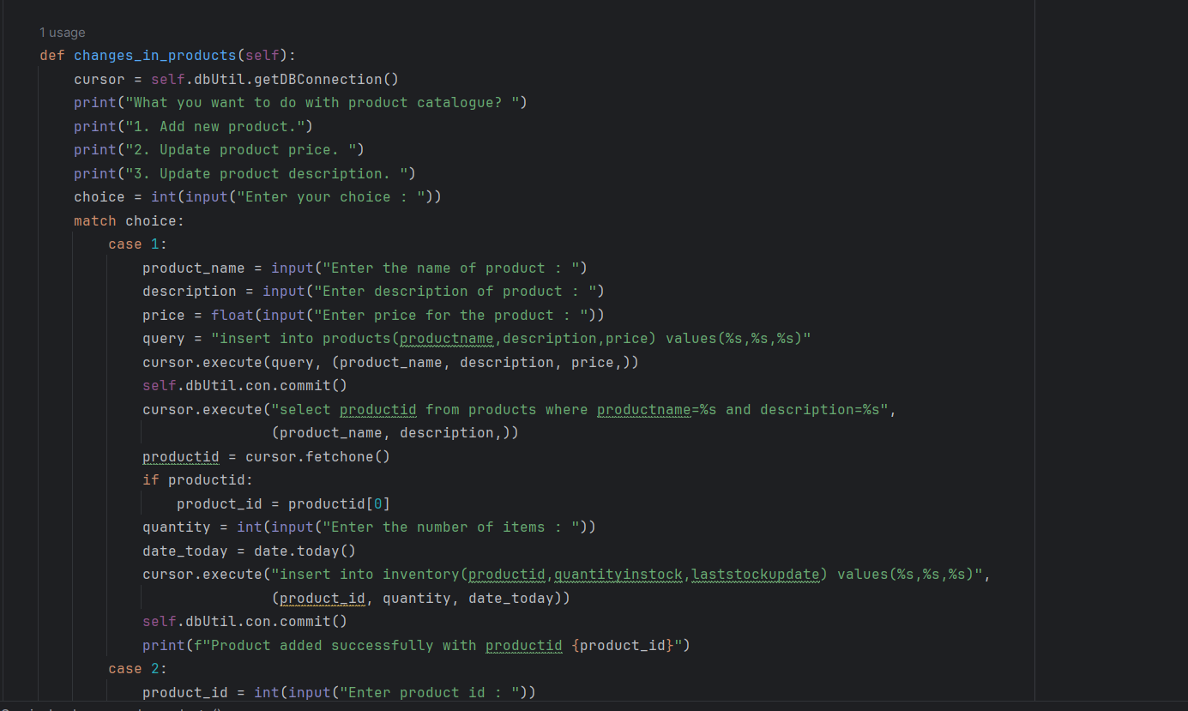

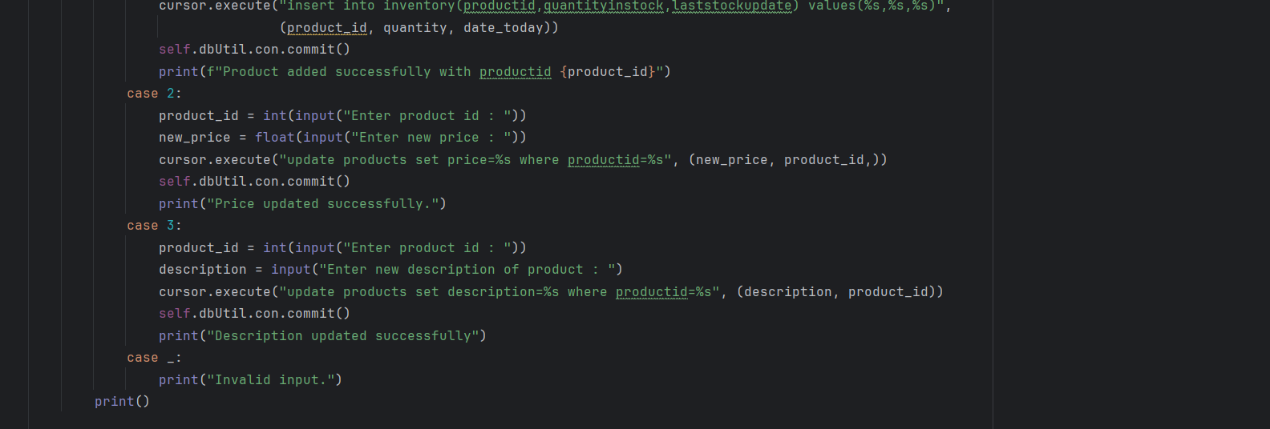

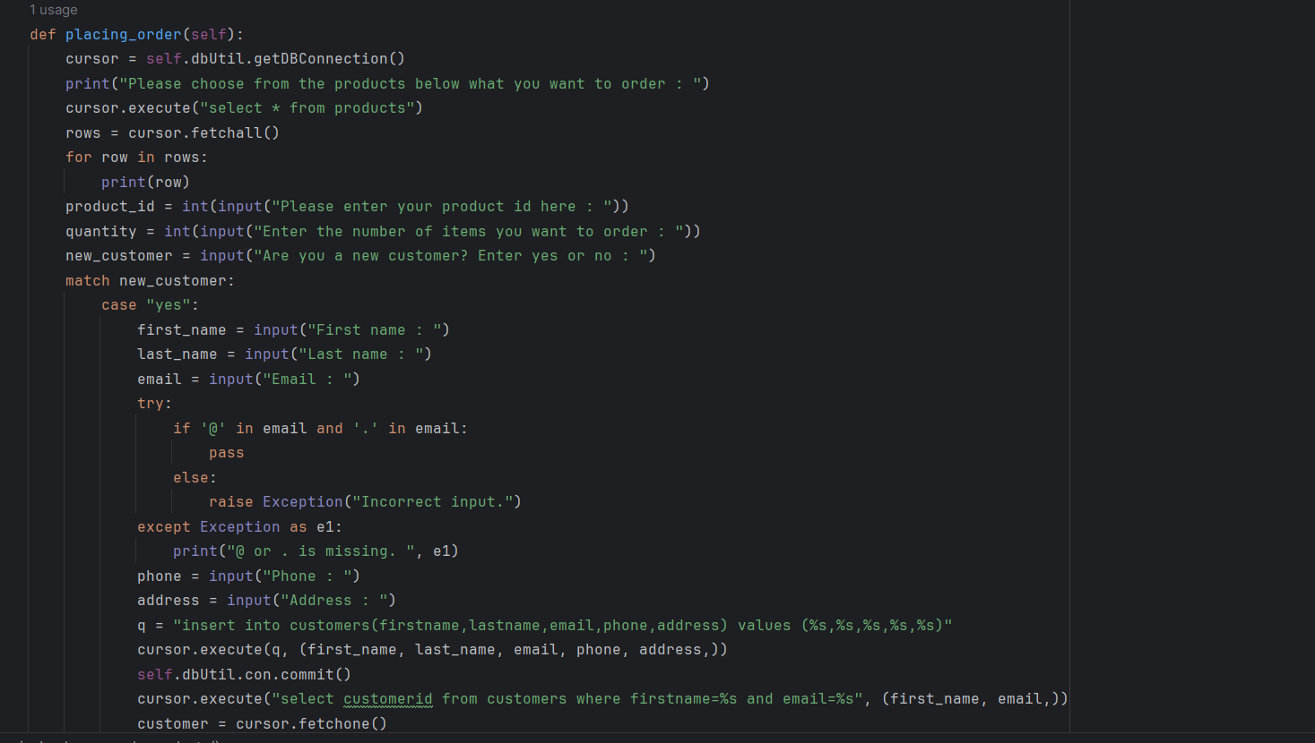

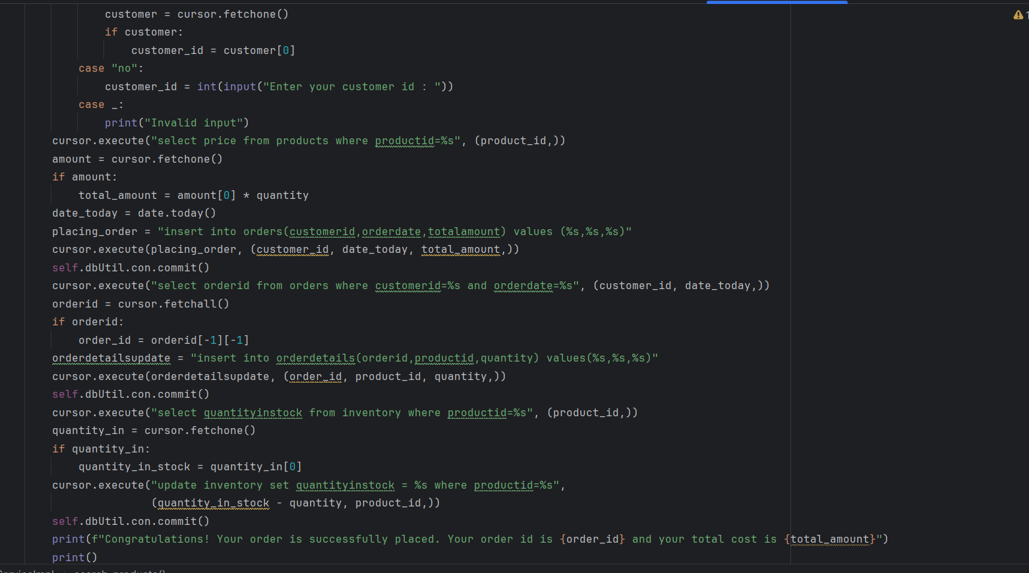

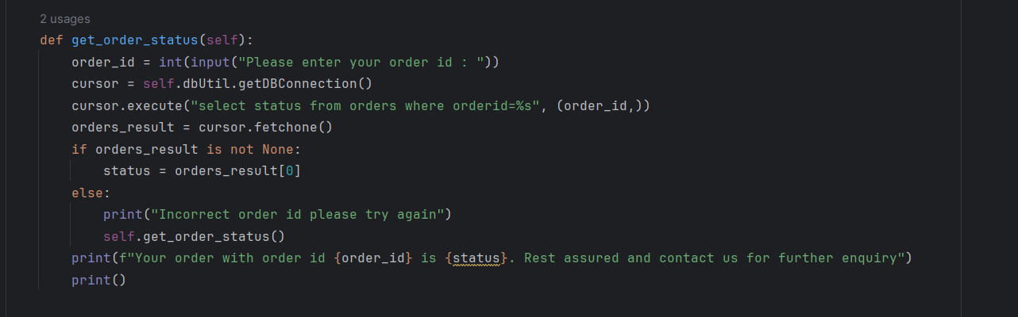

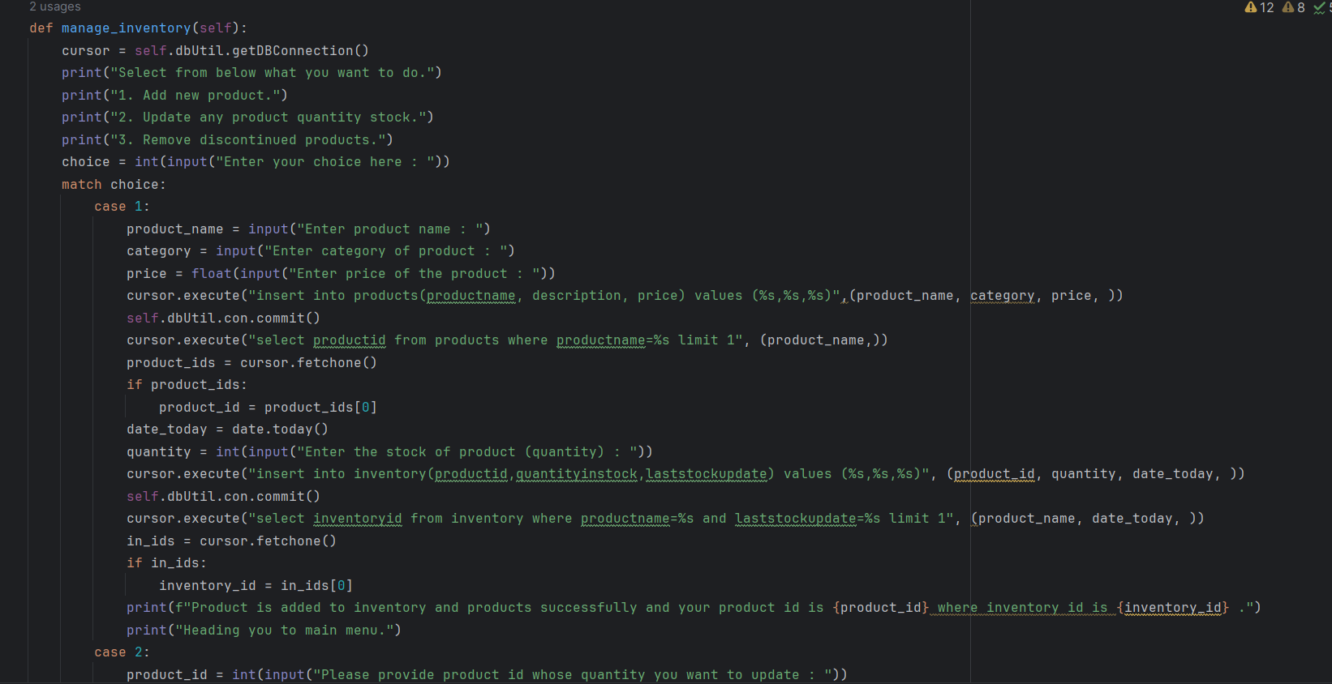

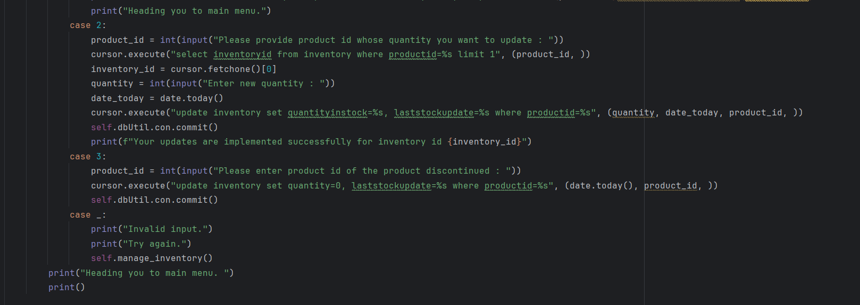

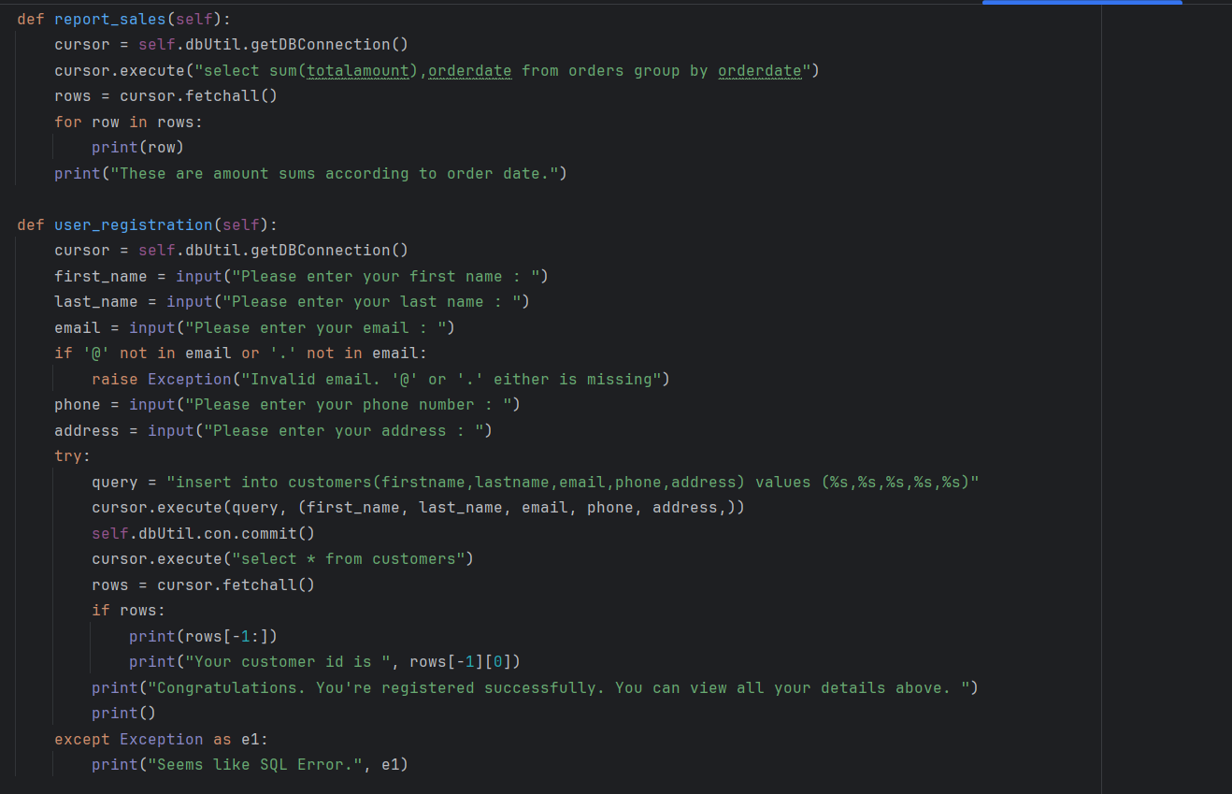

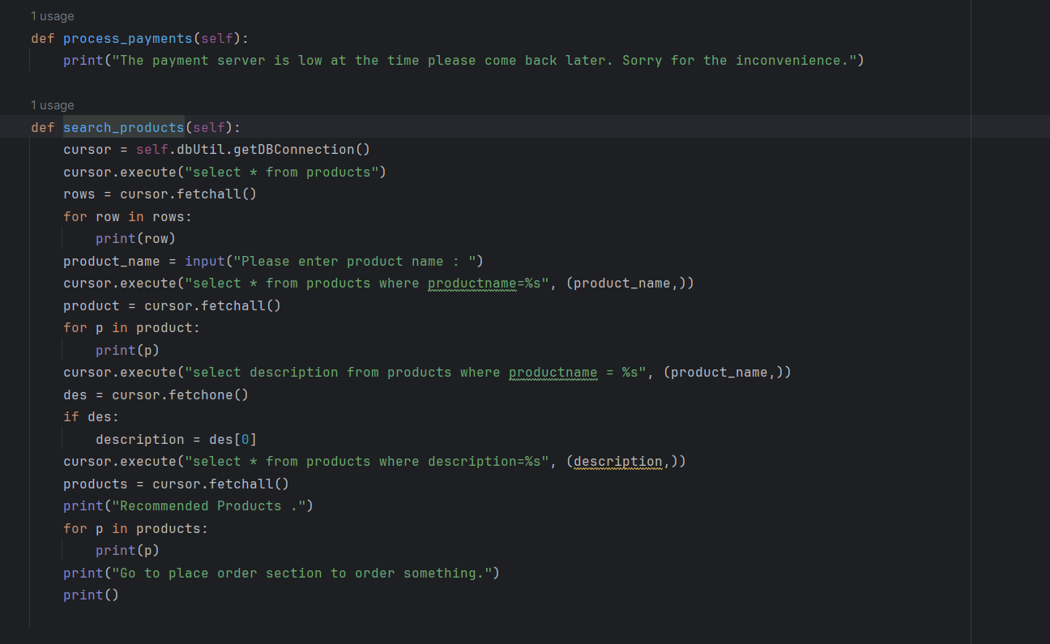

**Customer Class Implementation:**

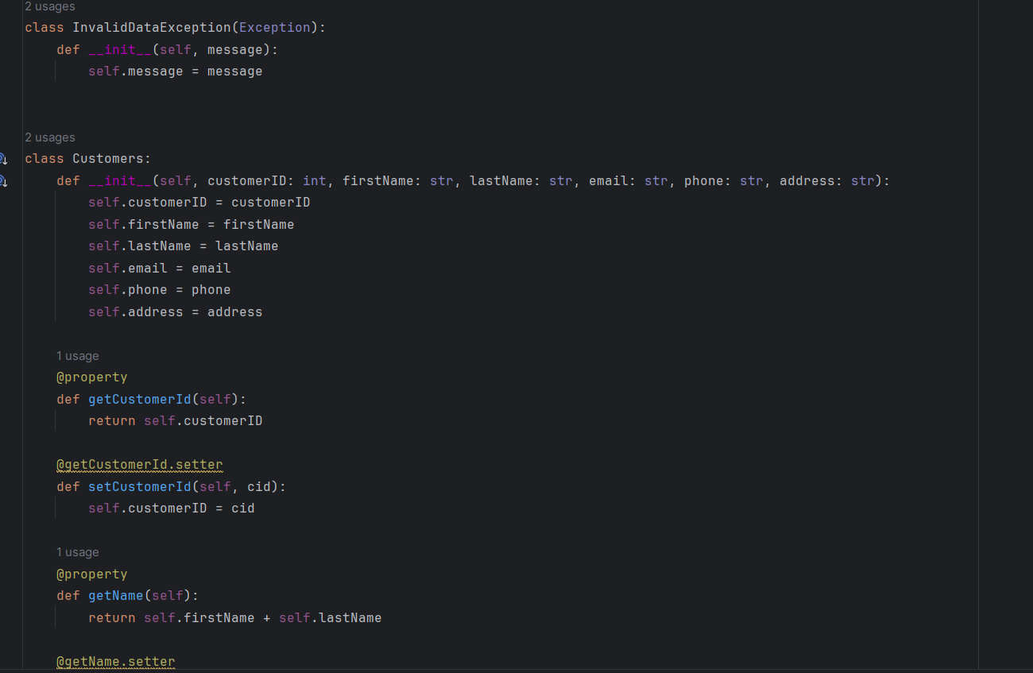

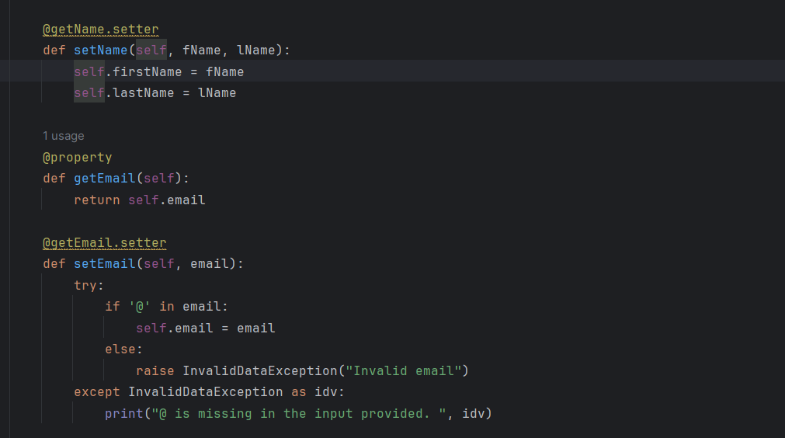

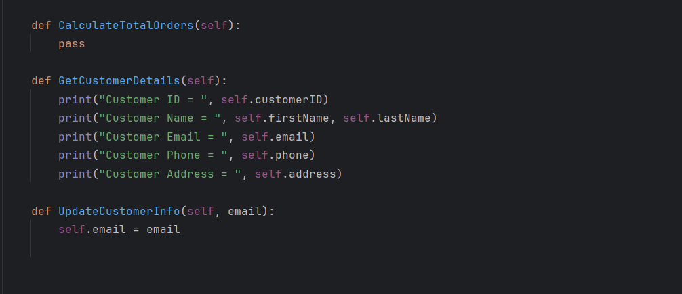

**Products Class Implementation:**

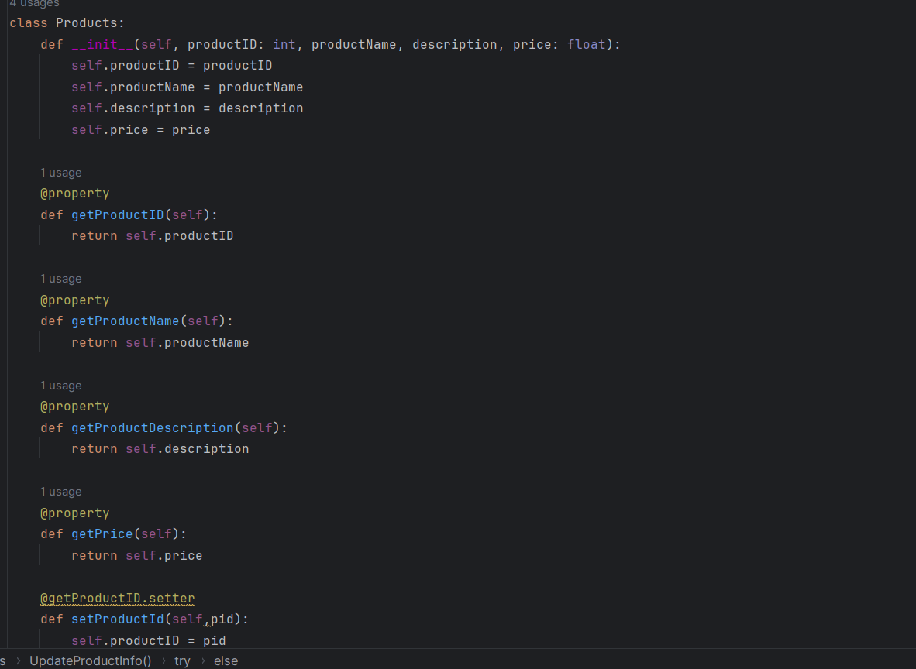

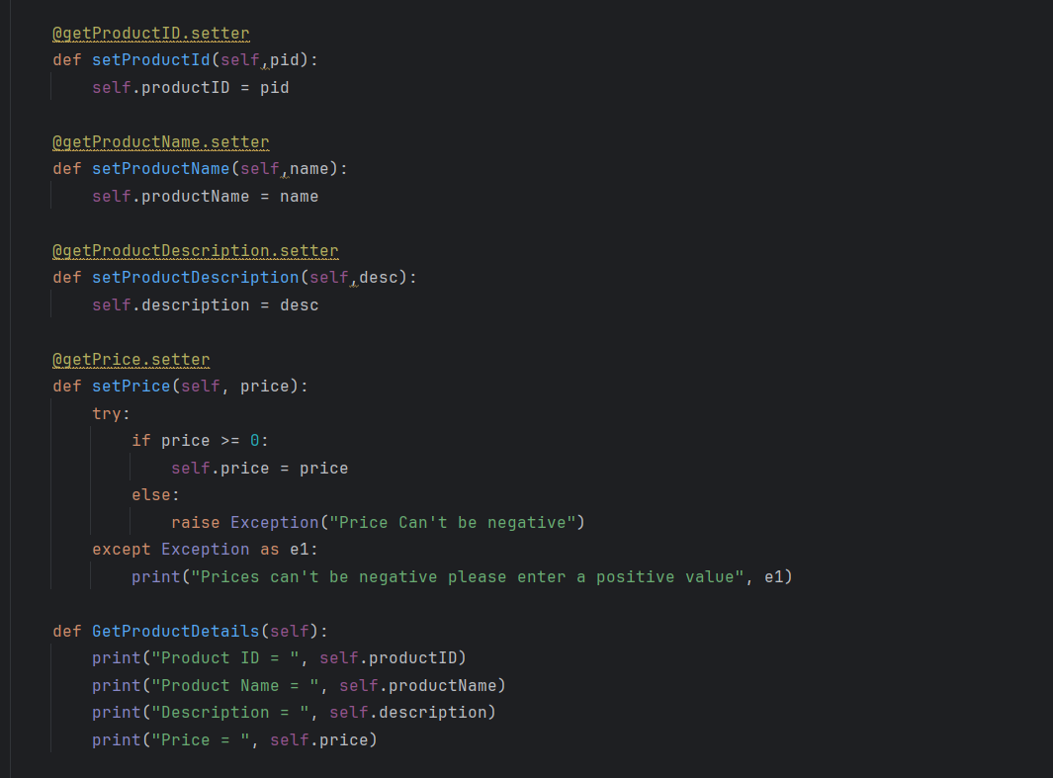

**Orders Class Implementation:**

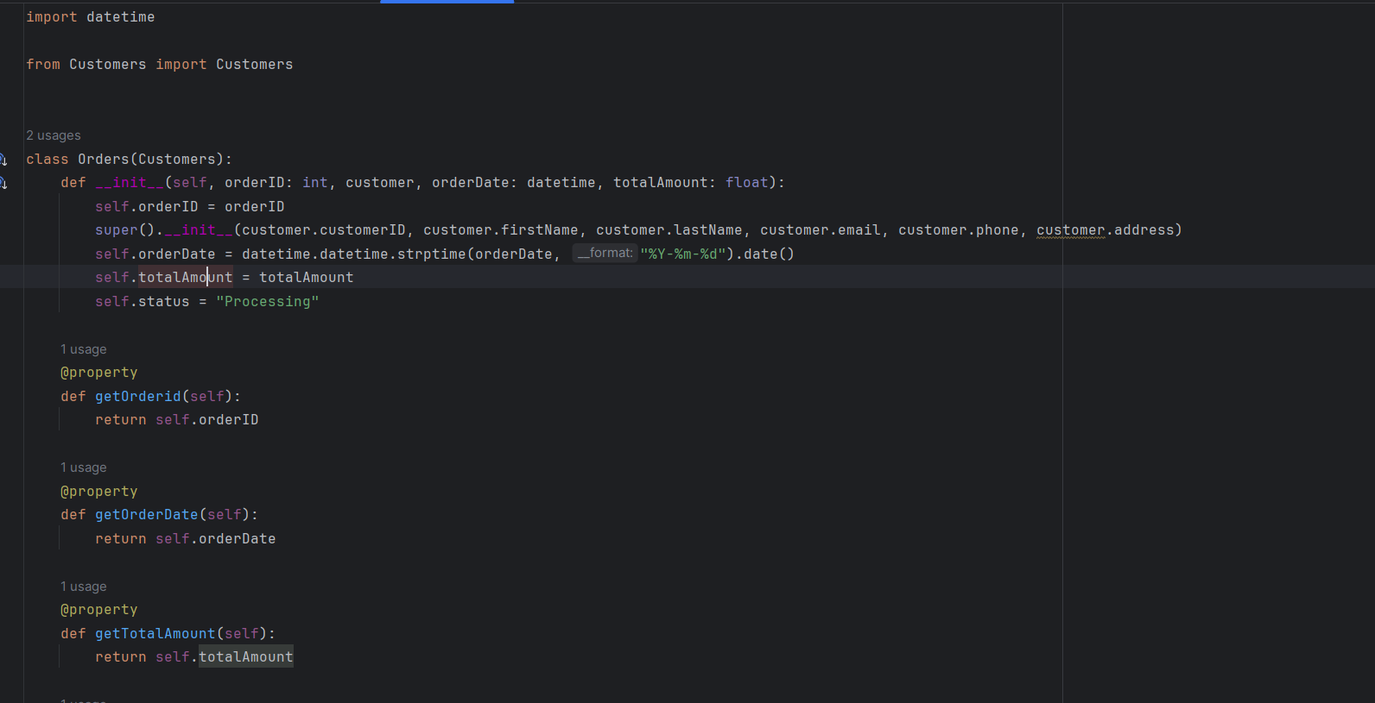

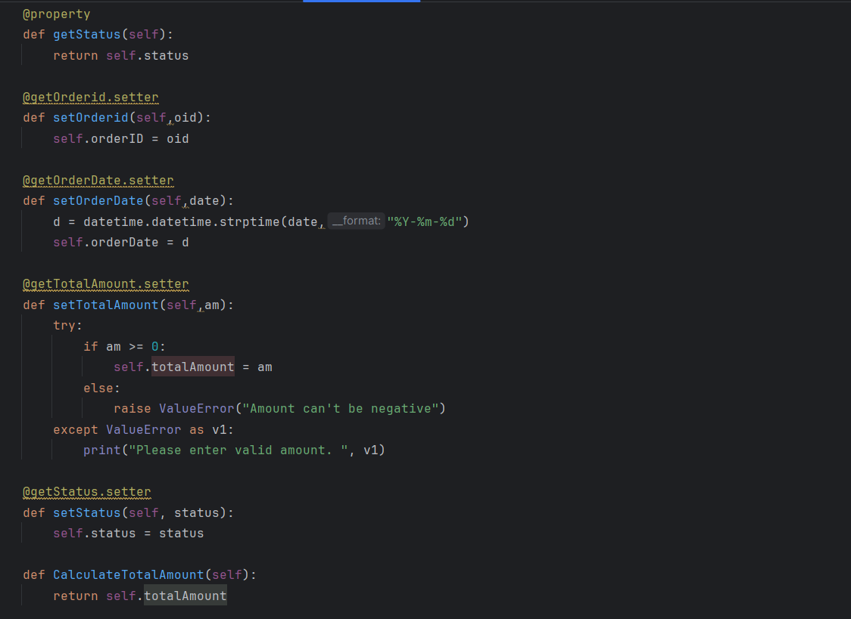

**OrderDetails Class Implementation:**

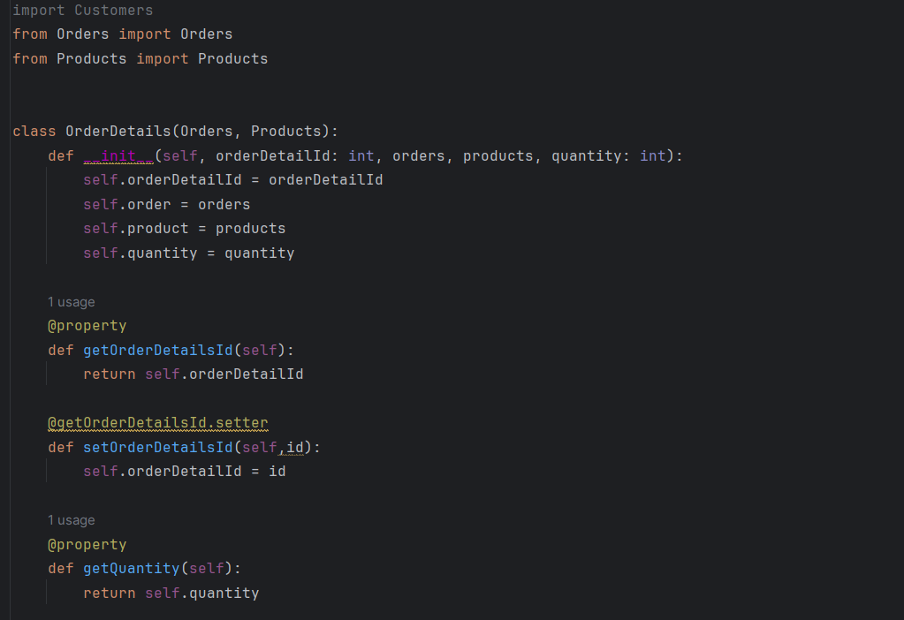

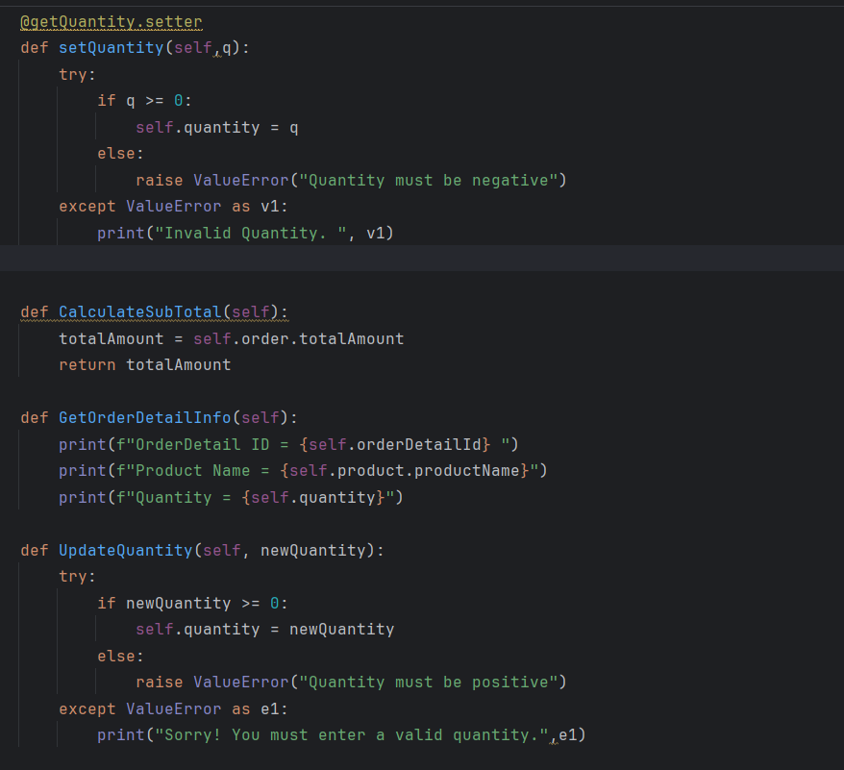

**Inventory Class Implementation:**

